List of Icons and Visual Elements for StarCellBio

ICONS

On every page or almost every page:

* Home icon (house)
* Contact us (letter)
* User Guide (“?” icon)
* Knowledge Library (textbook or microscope looking at a book)
* Lab Notebook (notebook with pencil)
* Warning icon (“!”)

Technique icons

These are not currently shown in the user interface documents, but these could appear next to the name of each technique throughout the user interface. For example, at the bottom of the home page, Assignment overview page, and also in the knowledge library.

* Western blotting – western blotting gel

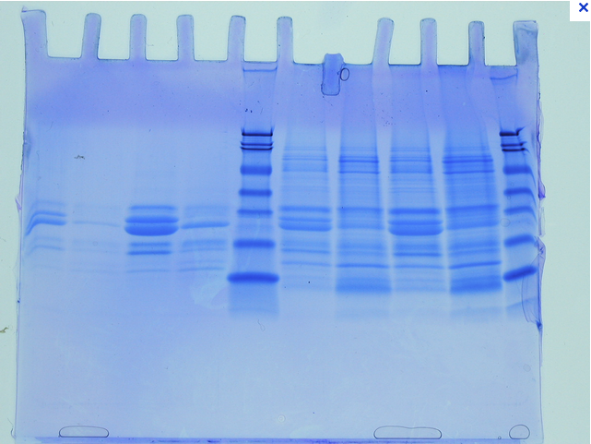

* Flow cytometry – Flow cytometry is a technique that shines lasers at cells to determine the size, shape and many other things about the cell. Perhaps an icon of laser light looking at a cell and diffracting in many directions, such as these images?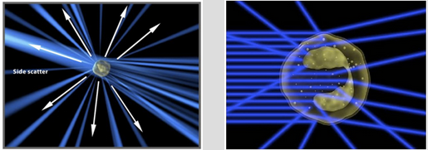
* Microscopy - microscope

Experimental Set-up Page

* Icon for each row in the Experimental Setup table - Plate of cells to indicate to the user that each row represents treatments to one plate of cells.



* Delete (trash can)
* Copy (multiple pieces of paper)

Western blotting

* Progress bar or some other image to show the passing of time while the message “Transferring Gel” is shown (page 15)
* Tool to help students measure protein size (page 17, 19)

VISUAL ELEMENTS

1. StarCellBio Logo. See other star logos on the [star.mit.edu](http://star.mit.edu/) website. Here is the current STAR logo:Alison Brauneis:Users:AlisonBrauneis:Dropbox:Logos:STAR:Star Logo Ver1.ai
2. Illustration on the homepage. For the illustration on the home page, we would like the picture to bring together a laboratory bench, cells, and the three experimental techniques that will be in the first prototype of StarCellBio. I have attached a reference picture that brings together a laboratory bench, a microscope, a computer, and a plate of cells. Additionally, the right of the picture is supposed to represent cells (although I don't think the cells look very accurate, scientifically) that someone is looking at under the microscope. One idea to incorporate the flow cytometry technique is to put some flow cytometry data on the computer screen (flow cytometry is normally analyzed on a computer). To incorporate western blotting, we thought we could put a western blotting apparatus on the bench. The typical western blotting apparatus is the box with a green lid (they always have a green lid).





1. MIT logo – see [this page](http://web.mit.edu/graphicidentity/logo/index.html) for reference
2. Image of the Western blotting steps. The user interface documents actually shows you multiple steps of the western blotting process. These two videos provide an overview of the western blotting process:

<http://www.benchfly.com/video/120/how-to-load-and-run-sds-page-gels/>

<http://www.benchfly.com/video/106/pouring-acrylamide-gels-for-sds-page/>

Here are the details for each page:

* Page 10: thumbnail should be a blank gel with 15 wells at the top, like this one. There should not be any protein samples in the wells (ie: no blue stuff in the wells). This picture shows a gel that can be purchased. The gel (with the lanes) is being shown between two plastic plates. The gel is very thin (1-2 mm) and needs the plates to support it at this stage. The video shows someone pouring their own gel. Note that this image shows a gel with 10 lanes and we will be using 15 in StarCellBio.

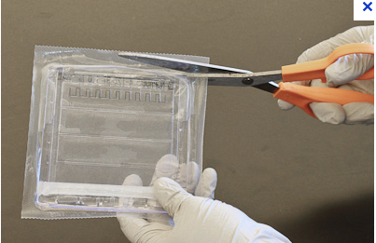

* Page 11: grayed out version of the gel on page 12.
* Page 12: The gel should be loaded (ie: blue stuff in the wells). The lane on the right (lane 15) is always reserved for the marker. This lane will not be loaded unless the student has clicked the “Load Marker” button. I can’t find a great picture of a loaded gel. The video does show this step though.
* Page 13: All wells in the gel are now “loaded”.
* Page 14: Once the student clicks on the “Run Gel & Transfer” button, the gel will run. This will be a very brief animation of the gel running, which means that a blue line (representing the blue dye) will move down the gel and the marker (the colorful bands in lane 15) will move down the gel as well. We would like to use the marker shown in the right hand column of the picture below in StarCellBio. The protein sizes that each colorful line corresponds to are on the left of the picture. I think the video is the best place to see the blue dye front migrating down the gel as it is running.

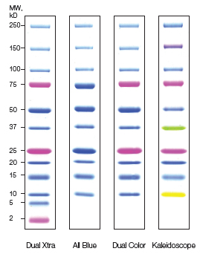

* Page 15: This is showing a message (and progress bar or image showing the passing of time) that will appear to indicate to the student that the proteins are moving from the gel to a piece of membrane.
* Page 16, 18: Now the proteins have been “transferred” from the gel onto a piece of membrane. The membrane is a white square that looks like this:



The membrane will have the colorful (marker) bands in the right hand lane. The membrane no longer has wells and so we must label each lane (1-15) to show the students where the wells used to be.

* Page 17, 19: The membrane has now been exposed to a piece of film. Although the film is being represented as a white box here in the user interface documents, it actually looks like the image below. The film should be gray and the bands will appear black. The developer will actually render the bands. The marker, which was previously colorful bands in lane 15, does not show up on the film. Instead, small numbers representing the position of each of the bands will appear on the right side of the film.

